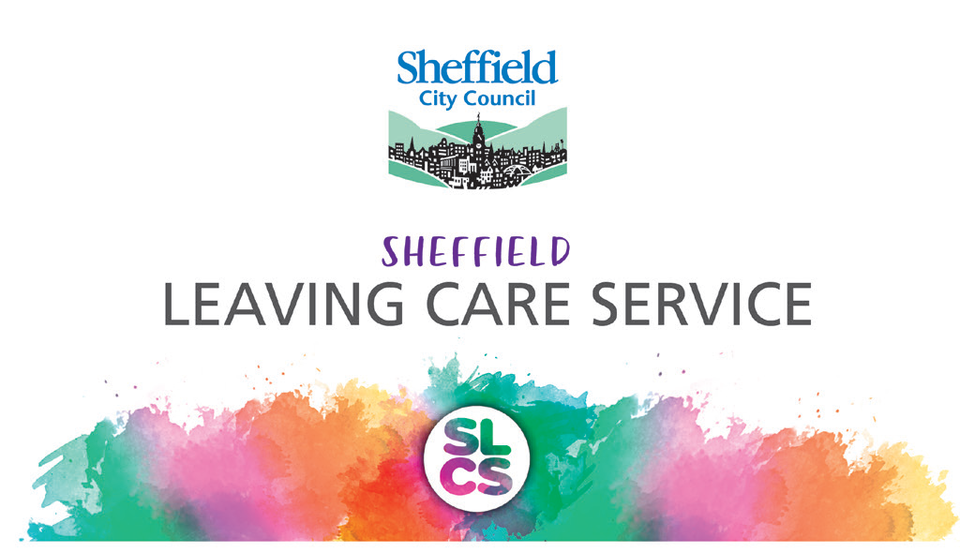

Financial Guidance for Care Leavers

**2019**

Contents

|  |  |
| --- | --- |
| What is your Leaving Care Legal Status? | 3 |
| Money |  |
| Income Maintenance | 4 |
| Living Independently |  |
| Accommodation Costs | 5 |
| Housing Bonds/Rents/Deposits | 5 |
| Setting up home allowance | 5 |
| Insurance | 6 |
| Education and Training |  |
| Assistance for Education & Training | 7 |
| Higher Education Assistance | 7 |
| Bursaries Grants and Loans | 8 |
| Accommodation Costs | 8 |
| Maintenance Payments | 8 |
| Graduation | 8 |
| Additional Leaving Care Service Payment | 8 |
| Vacation Accommodation | 8 |
| Celebration of Achievement | 9 |
| Other Help |  |
| Clothing Allowance | 10 |
| Maternity Clothing | 10 |
| Birthday and Cultural Celebrations | 10 |
| Driving Lessons | 11 |
| Passport | 11 |
| Dental and Optical Assistance | 11 |
| Summary of Payments | 12 |
| What you might need when setting up home | 13 |

**What is your Leaving Care Legal Status?**

**If you were in the care of the local authority on or after your 16th birthday you may be entitled to some financial support from the local authority as a care leaver.** This flow chart will help you to understand what your leaving care legal status is which will help you to understand your entitlements. Use the colour code throughout this guide to help you identify what support you can receive. 

**Money**

EYP

RYP

**Income Maintenance (IM)**

Income maintenance payments of £60 a week are made to you if you have reached the age of 16, are living independently in the community (i.e. not with a foster carer or in a residential home) and are unemployed. Payments will continue until a change in your circumstances i.e. you gain employment or you reach the age of 18 and are able to claim benefits through the DWP.

The £60 will be paid directly to your bank account on a weekly basis unless detailed otherwise in your pathway plan. Where it is felt to be in your best interest payments may be made in the form of food vouchers or we can top up your utility payment cards.

The Leaving Care Service is able to make arrangements on your behalf to deduct money and pay accommodation service charges from your weekly income maintenance. This would be agreed with your Personal Advisor and detailed in your pathway plan.

If you are in employment or on a paid training scheme such as an apprenticeship your income will be assessed and supplemented to the level of income maintenance if required.

If you are in employment you may still qualify for some financial assistance depending on how much you earn and your bills.

If, at any point your circumstances change your PA will discuss undertaking a needs assessment with you. This will help decide the level of income maintenance you will receive.

If you have returned to live at home, your entitlement to income maintenance will reduce to £10 per week and be paid for a period of 6 months at which point you will become a Qualifying Young Person.

Young people living in Foster Care or a Residential Home will receive pocket money and financial support supervised by the Fostering Service or Residential Service.

**Living Independently**

**RYP**

**EYP**

**Accommodation Costs**

Up until the age of 18, accommodation costs will be supported by the Leaving Care Service and payments will be based on your circumstances. In most cases property rental costs will be met in full. However if you are in employment and earning above Income Maintenance levels (£60), an individual assessment will be made and an appropriate level of contribution agreed by a Senior Fieldwork Manager. This applies to care leavers living both in and out of the city. The Leaving Care Service will make payments to the accommodation provider on your behalf.

FRYP

**RYP**

**EYP**

**Accommodation Costs**

If you are accommodated in Supported Lodgings or with a Staying Put provider, there is an expectation that you pay a contribution to your board (approximately £20 per week) this is expected to cover food costs. If you have chosen to do your own cooking, this payment may be reduced. All details will be agreed and recorded in your living together agreement.

FRYP

RYP

EYP

**Housing Bonds/Rent /Deposits**

When looking to secure your own tenancy the preferred option of the local authority is for you to secure accommodation in social housing, through a housing association or voluntary sector housing scheme. This is because the service works closely with these organisations, making them better placed to support your journey to independent living.

Support for private tenancies will be considered on an individual basis, but are not the preferred option.

The Leaving Care Service promotes tenancies with Sheffield City Council as the preferred option.

If you decide to take up a tenancy with a private landlord they would need to accept housing benefit/universal credit. Bonds and deposits can be taken from your setting up home allowance with the agreement of a Senior Fieldwork Manager in the Leaving Care Service.

FRYP

RYP

EYP

**Setting-up Home Allowance**

Dependent on your circumstances you could receive **up to a maximum of £2000** setting up home allowance from the Leaving Care Service. You may also be eligible for the Local Assistance Scheme. If you meet their criteria you may be able to apply for up to £1000 worth of goods to set up your home and support your transition to independent living.

**What it pays for?**

If you meet the criteria for the Local Assistance Scheme, you will be able to select white goods (fridge, washing machine etc.), as well as choose from a standard catalogue of basic furnishings and furniture e.g. carpets, bed, sofa, table and chairs. Any remaining balance will not be available in cash towards items outside this scheme. Your Personal Advisor will be able to work with you in order to identify how best to access this scheme. Please note this element of finance will only be available to young people living in Sheffield. If you do not live in Sheffield your Personal Advisor will be able to support you to apply to any similar scheme available in your area.

The setting up home allowance is a grant that is intended to support you to move to a more independent living situation. This grant is held by the Leaving Care Service, your individual needs will be assessed by your Personal Advisor and an agreed amount will be available to support you with the purchase of additional items to set up your home. A list of suggested items can be found at the end of this document. Whilst your wishes and feelings will be taken into account, the Leaving Care Service will make the final decision in relation to setting up home allowance being issued.

If you are a young person entering supported lodgings you may be entitled to receive some setting up home allowance. A record of the amount you receive will be recorded and this will be taken off any later setting up home allowance you may receive if you move to your own tenancy.

**Insurance**

The service expects that all young people take out the necessary contents insurance to protect their belongings. The service will not be liable to replace an individual’s belongings in the case of damage or theft. Payment for insurance should come from a young person’s setting up home allowance or their general income.

**Education and Training**

EYP

RYP

FRYP

**Assistance for Education and Training**

As an Eligible, Relevant or Former Relevant Care Leaver you may be able to get financial support of £1200 a year direct from your school, Further Education College or Learning Provider. The 16-19 Bursary is guaranteed for care leavers aged 16-19, and discretionary learner support may be available for older learners. These payments are in addition to your income maintenance payment if you are an eligible or relevant young person, and are expected to cover books, course materials and equipment required.

If you have been unable to access a learning allowance or bursary, further support to cover travel and course materials is available from the service. If you are engaged in a full time course (16hrs or more per week) you could receive up to a further £30 per week during term time. For young people on part time courses this amount will be adjusted accordingly:

* 16 hours - £30
* 8 hours - £15
* 4 hours - £7.50

This payment is conditional and **you must** provide your consent for the service to share information to confirm attendance on the course to ensure continuation of payments.

If your course equipment requirements are particularly expensive then a further allowance of up to £100 may be granted. In these cases we would ask you to provide the full/kit list requirements in order to thoroughly assess your needs.

If you are an Eligible or Relevant young person and are caring for your own child/ren whilst undertaking further education your need for support with childcare costs will be considered. In the first instance the education provider should be approached to understand what support they offer.

Your PA will support you to apply for ‘Care to Learn’ (<https://www.gov.uk/care-to-learn> ) to help with childcare costs while you study.

FRYP

QYP

**Higher Education Assistance**

As a Former Relevant young person you are able to request support to pursue higher education up to the age of 25

**Bursaries, Grants and Loans**

As a young person attending University you will be expected to claim all the bursaries and grants available to you through the academic institution of your choice and your Personal Advisor will be able to help you to do this.

You will most likely need to apply for a student loan to cover your course fees known as a ‘Tuition Fee Loan’ and this is paid directly to your chosen university. In addition, you will need to apply for a ‘Maintenance Loan’ this is available to all full time students and is means tested. This loan is expected to support the costs of things such as food and bills.

**Accommodation Costs**

In order for young people to attend university the Leaving Care Service will support your accommodation costs on an annual basis up to £5,500 outside London, £7,500 inside London/Oxbridge. You will be supported by your Personal Advisor to find a property that best suits your needs.

**Maintenance Payments**

The Leaving Care Service will help you with your living costs whilst at university by paying you a maintenance payment of £60 per week during term time, dependant on attendance. Consent for the university to share information with the Leaving Care Service must be given.

**Graduation**

The university you attend may provide a grant for care leavers to pay for gowns and photos at graduation. If this is not the case the Leaving Care service will pay £100 contribution for University Graduates towards gowns and photos if you are attending a graduation ceremony.

**Additional Leaving Care Service Payment**

In addition the Leaving Care Service will pay a bursary of £2000 to any Former Relevant young person attending higher education. This payment is usually in instalments across the duration of the course. Payment arrangements will be agreed and detailed in your pathway plan.

**Vacation Accommodation**

Depending on your living arrangements whilst at university you may require accommodation support during holiday periods. The Leaving Care Service will meet the cost of this accommodation and this will need to be agreed with your PA.

**Note:** young people without settled status in the United Kingdom, will need to discuss university applications with their Personal Advisor at the earliest opportunity to ensure their eligibility for funding. You may not be entitled to higher education support until you have been granted leave to remain in the country.

**Celebration of Educational Achievement**

FRYP

RYP

EYP

The service may make a celebration payment in circumstances where young people achieve a qualification or significant success up to the age of 21 years old.

**Other Help**

**Clothing Allowance**

RYP

EYP

If you are an Eligible or Relevant young person living independently in the community you are entitled to a clothing allowance. Your needs will be assessed by your Personal Advisor.

If clothing is lost or damaged you may apply to the Leaving Care Service for assistance. Any assistance will be based on an assessment of your personal circumstances.

If you have been released from serving a custodial sentence up to the age of 18 you will be given a clothing grant of £70, this will follow a supervised spending procedure and will be deducted from any further clothing grant allocations you may receive at a later date.

FRYP

RYP

EYP

**Maternity Clothing**

If you are pregnant and require maternity clothing your needs will be assessed by your Personal Advisor.

Pregnant young women receiving income maintenance are entitled to claim Healthy Start Vouchers, and may be entitled to further benefits under government schemes. Your Personal Advisor will be able to support you with this.

**Birthday & Cultural Celebrations**

FRYP

RYP

EYP

If you are an Eligible young person living independently you are entitled to a birthday gift to the value of £150. This should preferably be a gift that can be bought in discussion with your Personal Advisor, or can be made available via a selection of gift vouchers. You will also receive £150 for Christmas or other cultural celebrations such as Eid (1 payment per year).

If you are a Relevant young person living independently you are entitled to a birthday gift to the value of £75. This should preferably be a gift that can be bought in discussion with your Personal Advisor, or can be made available via a selection of gift vouchers. The same applies to Christmas or other cultural celebrations such as Eid. (1 per year).

For Former Relevant young people the value of the gift you receive is dependent on your age:

|  |  |  |
| --- | --- | --- |
| Age | Birthday payment | Celebration payment |
| 18 | 150 | 50 |
| 19 | 50 | 50 |
| 20 | 50 | 50 |
| 21 | 150 | 50 |

FRYP

RYP

EYP

**Driving Lessons**

The Leaving Care Service will purchase a provisional driving licence for all young people.

For 17 – 21 year olds engaged in education training or employment the Leaving Care Service will support you in learning how to drive by paying for ten driving lessons, one theory and one practical test. You must pass your theory test before lessons will be paid for.

If you are over 21 then an individual needs assessment will be applied.

FRYP

RYP

EYP

**Passport**

The leaving care service will pay the cost of a passport application or renewal once. This would usually be purchased if and when you are going on a holiday abroad, or at the point of your 21st birthday, whichever is soonest.

**Dental and Optical Assistance**

If you are under the age of 19 and in full time education you will normally not need to pay the majority of NHS charges. If not you can claim assistance using an HC1 form which will entitle you to dental and optical care. Your personal advisor will support you in completing this.

**Summary of Payments**

**What you might need when setting up home**

|  |  |  |  |  |
| --- | --- | --- | --- | --- |
| **Furniture** | **White Goods** | **Kitchen Equipment** | **Soft Furnishings** | **Other Essentials** |
| Bed | Washing Machine | Plates and Bowls | Duvet & Pillows | Smoke Alarms |
| Wardrobe | Fridge/Freezer | Glasses and Mugs | Bedding x 2 sets | Contents Insurance |
| Chest of Drawers | Cooker | Cutlery | Towels x 6 | TV Licence |
| Sofa/Arm Chair | Microwave | Pots & Pans | Lamp/Lampshade | Removal Costs |
| Table and Chairs | Vacuum Cleaner | Ironing Board | Curtains/blinds & fittings | Cooker fitting |
| TV stand | Iron | Bin | Bath mat | Washing machine plumbing |
|  | Kettle/toaster | Washing Up Bowl | Shower curtain |  |
|  | TV | Tea Towels | Carpets/Flooring |  |